Appendix

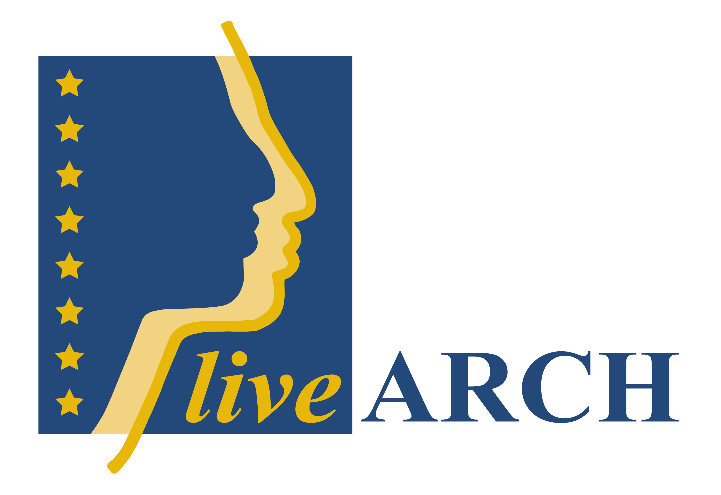

APPENDIX 1

Names and definitions of different kinds of phenomenon which are dealing with interpretations of mediation used in the partners countries.

Archäologisches Freilichtmuseum (Germany), Arkeologisk friluftsmuseum(Sweden)
See Archaeological Open Air Museum”

Terms covering this type of work

A living museum
Name for a museum that works with living history.
Living history of discoveries
Role-play - shows living history with an interactive scene

Ancient farm
Ancient Farm. Reconstructed ancient household
Time line
A series of events used to specify a period of time.

Iron Age Settlement
Reconstruction of an Iron Age village.

Time trail
A timeline put on a trail to walk round for visitors.

Museum “on the spot” to show what is found and hidden in the landscape

Site Museum
nearby a site - museum on the spot. On an original historic or prehistoric site. Gives a deeper explanation of the site history

Archeopark
Archaeological location of monuments, reconstructions or exhibitions

Arch Park
Can be an on-site museum, archaeological site with a conceptual walk, outdoors you can see archaeological finds - reconstructions of prehistoric periods

Museum Park
Out-door activities, exhibitions, garden, collections of exhibits in a natural environment with a litotes or reconstructed environment

Archäologisch Themapark
See Theme Park

Archaeological Park
An open-air site with archaeological remains referring to a specific archaeological cultural context
Archaeological-Ecological Centre
Stone Age centre
Histotainment Park

Centre working with experimental archaeology for the sciences

Centre of experimental archaeology
Site with experimental archaeological activity. Not necessarily open to the public.
Main focus - archaeological experiments related to demonstrations of ancient techniques. Different methods, techniques, analyses. Tests hypotheses or an interpretation, based upon archaeological source material.

Historical Archaeological Research Centre
Academic institution. Site with archaeological activity. Not open to the public - connection with a university. For scholars and students of history and/or archaeology Goals: Scientific research

Museum working indoors with exhibitions which houses artefacts and collections

Classic Museum
See Traditional Museum

Traditional Museum
View objects. Same as classic museum, collections of original historical artefacts and concept exhibitions

Archaeological Museum
Classic or Traditional Archaeological Museum following the standards of ICOM

What does this type of museum stand for?

Ecomuseum
a dynamic way in which communities preserve, interpret and manage their heritage for sustainable development

Used in all types of museum
Education in museums
Presentation of research projects

Culture or /and Nature Reserve

State Cultural Reserve
World heritage definition (UNESCO).

Terms for this type of work

Archaeological reconstructions
Reconstructions of archaeological findings.
Demonstrations of ancient techniques
Demonstration of these procedures to an audience e.g. flint-cracking
Scientific model construction
Model

Archaeo-techniques
Combination of Experimental Archaeology and demonstration of old techniques
Open air laboratory of techniques
An outdoor centre for experimental archaeology.

Archaeo-centrum
Centre for archaeological research.

Practical history
A research method focusing on the study of ancient technology and craftsmanship

The points listed below are stakeholders’ ideas on how to earn money from archaeology and history and lie outside the scope of our work

Medieval Market Scene without historic context.
Aim: Earning money
Temporary outdoor, re-enactors showing medieval life performed in historical town centre Theatre, Mixture, reconstructed, interpreting history - Market, selling and buying medieval replicas

Leisure Park about Middle Ages
activity park inspired by Medieval activities - amusement park, spending your leisure time. little care for archaeological or historical background, units without historic context.
Aim: to earn money

Mittelalterlicher Freizeit park
See Leisure Park

Commercial Archotainment
amusement site with archaeological theme, entertainment, fake excavation inspired by prehistoric activities

Theme Park
Aims: Financial, in combination with information, amusement, entertainment attractions, leisure design of a theme, seeing and experiencing topics from a specific theme or period

Visitor centre
A building with lavatory, coffee shop, souvenir shop etc… where visitors can relax

Appendix 2

Best Viking friends

First we would like to welcome you to the museum of Foteviken and its Viking reserve.

The goal with the reserve is that is shall be an open meeting place for “re-enacting” Vikings. Our aspiration from the museum is that living history shall be able convey to visitors and schools.

You as Vikings are always welcome to participate in the “re-enacting”, through participation of the activities, Viking crafts, selling, sailing and having fun at the same time.

To ease for as well you as us, we have put together our Viking rules to make corporation between the museum personnel and you as volunteer easier.

Application and registration
It is important that you announce you’re arrival in the information (you will find the administration in the yellow building down by the parking) so that we know that you are here, this concern’s both when you only shall be here for a couple of hours, to staying several days over night. If you arrive late at night you need to announce your arrival the following day.

Members
To participate and to be active in the village you need to be a member in the society.
As a member you and we will be ensured when you are here. The membership you can solve in the information.

Accommodation
All visiting Viking can always get roof over the head. If you have a plastic tent there is possible to set it up in the plastic camp. In the house of the slaves all visiting Viking are aloud to spend the night – specially the first night if you arrive late.
When you have announced you’re arrival and you don’t have a tent we can after a discussion with personnel, information and with accountable for the daily activities in the reserve decide if you can live in one of our Viking houses. This is only valid if you are active and participate in the daily life in the reserve, especially when the museum isn’t open.
As a member you are welcome to spend the night in hostel, but don’t forget to book a bed in time. A bed cost 50SEK/night. Leave your name in the information so that we know who you are. Our rules for the hostel correspond with the standard rules there is for other hostels.

Live in Viking houses
When you get access to a house, you shall of course make sure that it is comfortable for you and for visitors. But it is not allowed to “borrow” benches, pots or pans from other houses except from the house of the tradesman, where you can borrow items during the day. Your will have to be satisfied with what is available in your own house, if you want to cook you will have to move to another place where all required items is available.
We drink through horn, mug or jug. Food dishes you place on appropriate material. The wood supply shall be kept full and we will be pleased to see that the wood supply is fuller when you leave. Regular maintains and cleaning of the surroundings is of course included in your undertaking.

Toilettes, showers and more
Inside the walls it is totally forbidden to use the nature as a toilette. You can find toilettes in the shop building. These are closed after 17, but key to the toilettes is available and you will get information about this when you register. There are also toilettes in the red house and these are always open. Showers you’ll find in the basement of the red house, this shall be cleaned after usage.

Viking life
It is some years after 1134 in the Viking reserve and this means that no matter what time of the day it is, the age of the Vikings inure in the reserve. No modern equipment as mobile phone, sunglasses, watch, sneakers, cigarettes etc. is allowed. Inside tent shall all modern things be well hidden and the tent must be kept closed, the same concerns the Viking houses.

Marketing
Only Viking inspired products is approved for selling of guest. The King shall always approve new products. As a price tag you can use at piece of leather or fabric with written price on. The Viking reserve is a meeting place for all Vikings and we do not charge for marketing.

Safety
Remember that all doors in the Viking houses shall be unlocked during the night. Smoking is done outside the Viking area or in the pig house. It is totally forbidden to use or be under the influence of any drug inside the area of Foteviken museum.

Important phone numbers
Call 112 for emergent medical care, police or fire department.
During working hours the information has phone number XXXX.
NN has mobile phone number XXXXXX

www.foteviken.se
The complete rules for the Viking reserve can be found and read at our homepage “www.foteviken.se” under the menu button “Vikingaliv”. Here you will find the rule manual and information how we work with securing the quality in the Viking reserve.

Kind Regards,
NN with personnel
2009-06-16

Appendix 3 Visitors survey

liveARCH Standard Visitor Questionnaire 2009
Version 1 March 2009
Please modify question 3 and 10 add if necessary some of your own questions.

We hope you have enjoyed your visit to the ……………………… Please help us to improve our services to you by completing this questionnaire. Thanks for your help!

1.What factors made you choose to visit us today?
- Interested in the past
- Interested in the local region
- Weather
- Special event
- Family-friendly
- Educational value
- Entrance fees
- Environmentally friendly
- Other……………………………………

2.How did you hear about us?
- Recommended
- Our own brochure
- Other tourism brochure
- Our own web site
- Someone else’s website
- Newspaper/magazine
- Radio / TV
- Known from earlier visit
- Guide book
- Just passing by
- Other……………………………………

Where is your permanent residence?
………………………………………………….

4.Are you staying:
- At home
- at a B&B
- Self catering
- at a Hotel

5.How long are you staying in the area?
- Day trip
- 2-3 days
- 4-7 days
- 7+ days

6. Have you visited the………………….before?
- This is 1st visit
- 1-3 times before
- 3+ times before

7.How long have you been in the museum today?
- Less than 1 hour
- 1-2 hours
- 2-3 hours
- 3+ hours

8.Entrance fees
- Cheap
- About right
- Expensive, but worth it
- Too expensive

9.How did you enjoy the following: please rate where 5 is excellent and 1 is poor.
Please state a 0 if the activity or service was not used.

The reconstruction(s)
5 4 3 2 1 (why?) 0

The tour guide(s)
5 4 3 2 1 (why?) 0

Shop, toilet and other services
5 4 3 2 1 (why?) 0

Overall experience
5 4 3 2 1 (why?) 0

10.What other activities have you enjoyed or are planning to try in the area?
…………………………………………………………………………………….
…………………………………………………………………………………….

11.Would you recommend us?
- Yes
- No

12.How do we compare with other attractions you visited in the area?
- Better
- the same
- not as good

13.Any suggestions for improvement? …………………………………………………………………

Appendix 4 Formula for assuring quality

Quality assessment -

This document is important for the evaluation of the reconstruction – replica – re- enactment. Your work will be added to a database where others can find inspiration and perhaps learn something new. The document is to be used for both large and small items, from a house to a nail. And please, write only what you know.

Answer these questions in short sentences. Avoid the use of abbreviations. Please list literature including title, author, outlet date and publisher. Use this form for 1 (one) item only. If you have several items, please fill out a separate form for each.
Start the registration of this form by giving us your name and/or organisation and address.

Registration date: Ex 2002-11-18
Construction date/period: Ex 2002-09 to 2002-11
Name:
Organisation: name and type
Adr:
Tel. nr:
e-mail:

Type of object /item: E.g. “house”, “knife”, “trousers”, “brooch” etc.;

Designation of original:
1. Academic research:
1.1: Archaeological evidence; Where was the original found (e.g. Denmark, Sealand,
Tissø/Fugledegård, dwelling-house, fase 3)? Where is it published (author, title - periodica,
year, publisher, isbn/issn)? How did you become aware of the object? Approximate dating?

1.2: Other evidence; Old buildings, ethnological evidence, experimental archaeology, written sources, pictures or work of art, or - did you invent the object yourself?

1.3: Collaboration with Research Institute; Name and address of institutions involved in the process of creating this object?

1.4: Collaboration with other sites/organisations; Name and address of
persons or groups involved in the process of creating this object?

2. Authenticity:
2.1: Academia type or term; academic type description of the object recorded to literature.

2.2: Deviation from archaeological evidence and Regional identity; E.g. changes from the original farmstead structure, adjusted to the local conditions or using Gotlandic penannular brooches in Norway.

2.3: Relation to other findings; Other archaeological findings in close context with this
object that strengthen the interpretation of the object? E.g. other buildings, artefacts.

2.4: Relation to other regions; Was this object also found in other regions? If so, which?

Description of copy:
3. Accuracy
3.1: Relation/match to archaeological evidence; Describe any changes made, intentionally to
the object. E.g. a second door due to fire regulations or the sword had to be
shortened to make it safer for use or the original material could not be obtained or was too
expensive (please explain why; insufficient skills? insufficient finance? insufficient data?

3.2: Materials; What material(s) did you use?

3.3: Tools used; List tools used in creating the object. Separate replica tools from modern tools.

3.4: Quality of craftsmanship; E.g. educated or self learned blacksmith or bought by other producer (name and address).

3.5: Construction method; Short description of the work process.

4. Use
4.1: How; List of uses and where you intend to use the object.

4.2: History of uses; Have the uses changed?

4.3: Original main use; From archaeological evidence.

4.4: Changes due to use: Has the object been changed to adapt its usage? If so, how? Have other things been fitted/added to the object? If so, which things?

4.5: Finace, durability and repairs: This record is for large objects only, such as buildings. How was the replica paid for? Is it still good to use? Has there been need for repairs? If so,
why?

4.6: Documentation and publishing; Do you report back to a research institute on the use of the object (name and address.)? Do you or others publish anything on its use (if so list
references)?

4.7: Archaeological evidence — maintaining, developing and credibility; Do you consider your use as being consistent with the original use of the object? Is the wear and tear on the object consistent with archaeological evidence?

4.7: Archaeological evidence — maintaining, developing and credibility; Do you consider your use as being consistent with the original use of the object? Is the wear and tear on the object consistent with archaeological evidence?

4:8. Results achieved.
Do you think that the use of the object is similar to the archaeological interpretation?

4:9. Comments, what have we learned?

5. Photographs (at least 2) – if part of a database, write the database name. Show the object and the working process!

6. Blueprint/sketch

Appendix 5

Marketing plan

Content

1. Vision of the organization

2. Background

2.1 Number of visitors – previous years
Year | Number of visitors | Percentage change
2003
2004
2005
2006
2007
2008

2.2 Visitors by segment
Segment | 2004 | 2007 | 2008
Schools
Groups
Individual
Individual (children)
Individual (senior)
Cruise
Buss groups
Festivals (incl Individual)
Special arrangements (incl Groups)
Families | - | -

2.3 Visitors – they come from
Segment | 2004 | 2007 | 2008
Local | - | -
Region / city | - | -
The rest of you own country | - | -
Foreigners

2.4 How did we spend our marketing money
Segment | 2004 | 2007 | 2008
Advertising in local papers
National advertisement and articles (National tourist board or national papers /magazine)
Press trips/ invitations
Press release
Flyers
Invitation of important guests (stakeholders, politicians)
Posters
Web
Trade shows
Other

2.5 SWOT analysis
Strengths | Weaknesses
Opportunities (beyond your control) | Treats (beyond you control)

3 Marketing plan for year 2009

3.1 Our stakeholders

3.2 The axis of power and interest
3.3 Number of visitors – the coming 3 years
Year | Number of visitors | Percentage change
2008
2009
2010
2011
2012

3.4 Market segmentation

3.4.1Visitors per segment – the coming 3 years (prediction)
Segment | 2007 | 2008 | 2009 | 2010 | 2011 | 2012
Schools
Students / Academics
Groups
Individual
Individual (children)
Individual (senior)
Buss groups
Families

3.4.2 Activities and products per market segment
Segment | New products | Opening hours | Change season | Limited presentation | Full presentation | Offer new languages | Festivals
Schools
Students / Academics
Groups
Individual
Individual (children)
Individual (senior)
Buss groups
Families

3.4.3 Products

3.4.4 Activities per market geographical segment
Segment | Festivals | Membership | Advertising international magazines | Collaborate with others | New product packing | Offer new languages | New products | Season pricing
Local
Region / city
The rest of you own country
Foreigners

3.5 Our competitors

3.6 Critical success factors

4 Marketing budget for year

